Queen Mary Public School
Student-Family Handbook
2023-24

Mrs. Carrie Grant-Walker | Mrs. Jodi Letendre | Ms. T. Gerow | Ms. A. Cortez
Principal | Vice-Principal | Secretary | Secretary
cgrantwalker@srsd119.ca | jletendre@srsd119.ca | tgerow@srsd119.ca | acortez@srsd119.ca
306-763-7672 | 306-763-7672 | 306-763-7672 | 306-763-7672

Queen Mary Public School

REGISTRATION
All Parents/Guardians are to complete registration forms for their student (new & returning students). Forms are available at the office and on our school website. All students who require bussing can come into the school and complete a bus request form or complete it online https://www3.srsd119.ca/busgarage/transport/request.php
New students to the school, we ask that the parents/guardians accompany the student to register.
COMMUNICATION
Edsby is the platform used to report student absences, communicate with your child’s teachers, and view grades and assignments. Invitation emails are sent to families that are not yet registered. Please follow the instructions on the email to sign-up for Edsby and to add your children.
Bus Alerts - Bus cancellations
Please sign up to receive text updates from our school division transportation department. We suggest signing up for both SRPSD and Queen Mary bus updates.
- Text (902)701-9279 with the words “join srsdbus” to get updates from SRPSD bus via text message
- Text (902)701-9279 with the words “join qmbus” to get updates from Queen Mary buses via text message
VISITORS
While we strive to promote Queen Mary Public School as a welcome and inviting place, it is a building full of special young people and it is our responsibility to know who is in the building at all times. All visitors will be buzzed in using the Main doors on 15th Street West. All outside doors will be locked during the school day.
STUDENT DROP OFF AND PICK UP
Please take note of where and when you are permitted to park on the street in front of the school as there are bus loading zones marked. To ensure the safety of our students, student drop off and pick up is not permitted in the school parking lot.
MESSAGES FOR STUDENTS
The school will gladly pass along notes or messages to students from home at the nearest time least disruptive to their day. We ask that you please do not ask us to disturb classes unless an emergency is occurring.
Because student cell phone use is limited to educational purposes during the school day, parents should avoid contacting students on personal cell phones during class time.
CONTACTING THE SCHOOL
Contact with the school can be made in several ways; most efficient during school hours is to call our office @ 306-763-7672 or leave a message. Parents/guardians are always welcome to call or email with questions or information for the school.

BELL SCHEDULE
Outside Supervision Begins | 8:40
Morning Bell | 8:55
Period 1 | 9:00-9:45
Period 2 | 9:45-10:30
AM Recess | 10:30-10:45
Period 3 | 10:45-11:30
Period 4 | 11:30-12:15
Lunch | 12:15-1:00
Period 5 | 1:00-1:45
Period 6 | 1:45-2:30
Period 7 | 2:30-3:20
Dismissal | 3:20
ATTENDANCE
Students must attend school regularly and punctually. Parents/Guardians please notify the school before 8:30 a.m. if your child is going to be absent or late. Parents of students who have not been excused prior to the start of the school day will be contacted by our program, Safe Arrival. Notifications of absences go out at 9:15 am and 1:15 pm.
STUDENT ASSESSMENT REPORTING

Students/Guardians will receive feedback on student performance in many forms throughout the school year. Edbsy will be used as a communication tool and gradebook. You can access the parent portal at any time to monitor your child’s progress in each of their classes. There will be two formal reports sent home in January and June. Interim reports will be sent out two times during the school year and progress conferences will take place in November and March.

Interim Reports – Teachers will send home a report on the Factors Affecting Student Achievement (FASA) two times throughout the school year. This will be a snapshot of the students work ethic and will offer general comments, but it will not represent their achievement on outcomes.

Progress Conferences (Formally called Parent-Teacher Interviews). The purpose of the progress conferences is to discuss student progress and collaboratively set goals for the next part of the school year.
Progress Conference Dates: November 8 (3:30-8:30 pm) & March 14 (3:30-8:30 pm)

Report Cards – The purpose of the report card is to provide a summative evaluation of your child’s progress to date. Their achievement will be based on assessment of the outcomes in the Saskatchewan Curriculum. Report Card Dates: January 26 & June 26

DRESS CODE
School is a formal place of learning and dress should be appropriate for such an environment. Shirts of improper taste are not permitted. Clothing with messages that promote drugs or unhealthy lifestyles is not allowed. Clothing which creates discomfort in other students or staff will result in a conversation between students (and parents if desired) before a decision is made as to appropriateness. If a parent or student is not sure of the suitability of a piece of clothing, they may contact the Principal or Vice-Principal. Students may be asked to change clothes, cover the offensive piece or spend the duration of the day working independently. Hats, hoodies over the head, bandanas, or any other headwear is not permitted.
Outdoor clothing must be worn outside at recess/noon hour dependent on weather and at the staff’s discretion.
INDOOR SHOES & PHYS ED
Every student should have a pair of running shoes with non-marking soles to wear in the school. These shoes will also be worn in the halls and classrooms – only indoor running shoes will be allowed in the gym.
MEDICATION
Students will not be given medication without parental consent (this includes over the counter medications such as Tylenol or Advil). If you have a child who requires daily medication, please talk to the Principal or Vice-Principal.
ALLERGEN AWARENESS
Parent/Guardians are asked to complete the Allergen Awareness section of the registration form as it applies to their child. Please draw attention to any potentially dangerous allergies and the necessary actions to be taken should a reaction occur. This information is shared with all staff and posted in our staff room. Queen Mary is a nut free school.
BREAKFAST FOR LEARNING
Our breakfast program, available for all students, will continue again this year in the mornings.
LUNCH
Students will be given time to wash hands and then eat lunch in their classrooms from 12:15-12:35 before cleaning their respective rooms and going outside for the remainder of the lunch time from 12:35-1:00 pm.
Emergency lunches will be provided on a need basis.
There are always allergy concerns in a school. If you receive a notification as to limitations on food in your child’s lunch or snacks, please follow the recommendations given.
CANTEEN
The canteen is open every day at lunch. Students will have the opportunity to purchase healthy items during this time.
NOON HOURS AND RECESSES
Normally, students are expected to go outside during recess. Only in adverse weather conditions do students remain inside. They may use the washroom as they leave and enter the school. If the washroom is needed during recess, students may go inside with the permission of a teacher. If a student is ill and needs to stay inside, parents are asked to send a note.
BEHAVIOUR PROTOCOL
Students will always be expected to be responsible for their actions and their words. We continue to support an environment which celebrates the diversity that our student body has to offer. Bullying of any kind will not be supported by other students or tolerated by staff.
Initial consequences will be established by the staff member closest to the incident with administration involved where necessary. Families will be notified if consequences for behavior are necessary.
Vaping, Smoking, Drugs and/or Alcohol
  - There is no vaping or smoking permitted on school property at any time. This includes students, staff, families, and other visitors to the school.
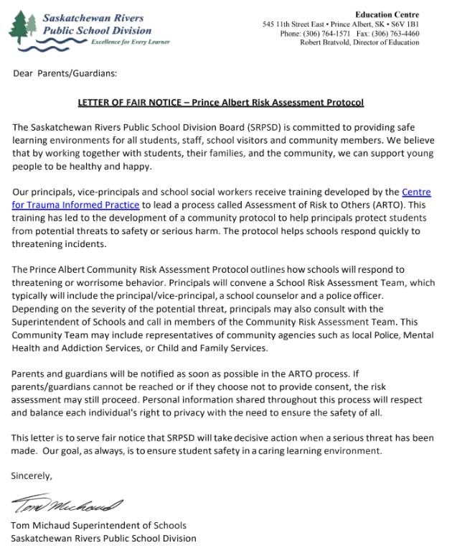
  - Students under the influence of drugs or alcohol will be sent home immediately. Families will be notified in advance.
CLASSROOM BEHAVIOR
Teachers are responsible for the discipline in the classroom. Students, you have the right to learn and the responsibility to allow others to learn. Students are expected to:
- work diligently in each class;
- respect the classroom routines and expectations set by each teacher;
- behave responsibly and respectfully;
- complete all work to the best of their ability; and
- use technology responsibly and as directed by teacher.

PERMISSION FORMS
Permission forms are sent home for field trips and special events. For some low-risk educational experiences, a note or message to families from the teacher via Edsby or email will be deemed sufficient (no permission form needed).
When your child comes home with a permission form please sign and return to the office or designated teacher promptly. If you have any questions surrounding an event please feel free to call the school.
Cubbies/LOCKERS
Students in Pre-K to Grade 4 will keep their belongings in their assigned cubby in their classroom. Students in grades 5-8 are assigned lockers. Students are to keep their belongings in their cubbies/lockers. Cubbies/lockers may be opened and inspected at the discretion of the administration team. In order to prevent theft or damage of student belongings, we would encourage all students to use their lockers and respect the privacy of others by never going into another’s locker. The school provides locks for the lockers in grades 5-8. Please refrain from bringing valuable items to school.
INTERNET
The internet is an environment of constantly changing, unregulated information that is used as an information resource. The use of the internet is a privilege, not a right, and inappropriate use may result in cancellation of this privilege.
Students are not allowed to access personal e-mail at school using school devices.
No visits to chat rooms, Twitter, Snapchat, Facebook or any other such social media platforms at any time.
CELL PHONES
We live in a technological era – some students carry cell phones. We must however, use them appropriately at school. Therefore we ask our students to be responsible phone users.
The use of cell phones is prohibited during class time unless permitted by the teacher for research, calculations, music, etc. which support student learning. Parents can leave important messages for students by calling 306-763-7672.
PARENTS: We respectfully ask that you do not contact your child(ren) on their cell phone during class time. Please call the school and leave a message. Most students are responsible and understand the proper use of cell phones. However, if students are not using their cell phone responsibly, they may be asked to turn it off and have it kept in the office until the end of the day. Parents will be notified if cell phone use is a concern.
VOLUNTEER DRIVERS
Saskatchewan Rivers Public School Division views the safety of students as a priority and as such there are two main protocols in place to assist in keeping students safe:
- Consent Forms – each time students are taken off the school grounds parents/guardians will be asked to complete a consent form acknowledging their child being allowed to take part in the event and giving permission for the taking and using of pictures by the school/school division.
- Volunteer Driver authorization forms – to be complete yearly by drivers of students (other than their own) to or from school sponsored events. The school cannot provide consent for transportation that takes place outside this agreement as it asks drivers to declare information such as; liability insurance on vehicle, driver’s license number, and agreement to abide by the Highway Traffic Act.

TRANSPORTATION
Bus Responsibilities for Students (AP 720- Student Conduct on School Buses)
Please review SRPSD policy for student conduct on school buses accessed from the link above or on the SRSD website. In summary, students are asked to:
- Be prompt and ready to meet the bus. Stand well back when waiting for the bus, until it has come to a complete stop.
- Board the bus and get off the bus in an orderly manner.
- While on the bus, respect the driver’s rules and sit in the place assigned to you. Remain seated while the bus is moving.
- Keep feet, lunch kits, school bags etc. out of the aisle. Oversized possessions are not allowed on the bus. Ask your driver if you have questions.
- No eating or drinking on the bus.
- If you will not be on the bus for some reason, please notify the bus driver.
- Dress suitably for the weather. Ie. Winter jacket, ski pants, toque, mitts in winter and at drivers discretion.
Students, please respect the rules and conduct yourself responsibility and respectful while riding the bus. Failure to adhere to respectful behaviour may result in a loss of bus riding privileges.
BUS CANCELLATIONS: COLD OR EXTREME WEATHER CONDITIONS
Administrative Procedure 551

Student safety is the Division‘s first priority. On occasion, weather conditions and/or road conditions may be such that safe transportation services are put at risk. The Division, therefore, authorizes the cancellation of bus operations as provided in this administrative procedure. Procedures When the temperature is at or below -40°C, bus runs will be cancelled. When the temperature is at or below 35°C and the wind chill temperature is at or below -45°C, bus runs will normally be cancelled. Wheelchair lifts will not be operated at or below -30°C. When the temperature is at or below -30°C, the developmental education buses will normally be cancelled. Bus run cancellations, as determined by the Manager of Transportation, can apply to the entire Division, to clusters of school attendance areas, or to individual schools. Regardless of temperatures or wind chill conditions, bus runs may be cancelled if severe storms or road conditions make travel dangerous. Weather information used for purposes of decision-making shall be as reported by the Weather Information Office of Environment Canada at the Prince Albert Airport, the Melfort Weather Station and the Spiritwood Weather Station.

Bus Alerts - Bus cancellations
Please sign up to receive text updates from our school division transportation department. We suggest signing up for both SRPSD and Wild Rose bus updates.
- Text (902)701-9279 with the words “join srsdbus” to get updates from SRPSD bus via text message
- Text (902)701-9279 with the words “join qmbus” to get updates from Wild Rose buses via text message
